1. Write a spring boot application to perform CRUD operations on Insurance domain. Looking at the real time application, you can decide the fields. Insert, Update, Delete and display all functionality data should reflect in the database table.

MAIN CLASS

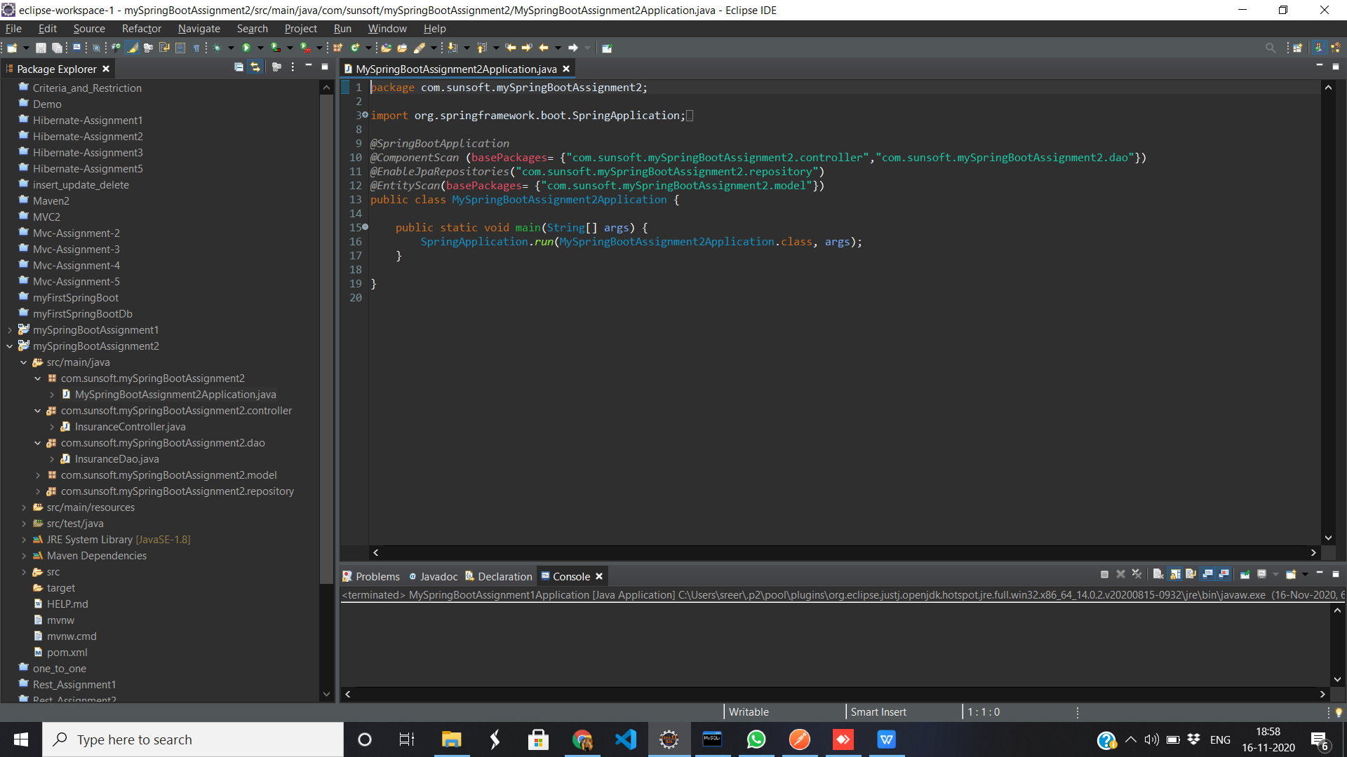

CONTROLLER CLASS

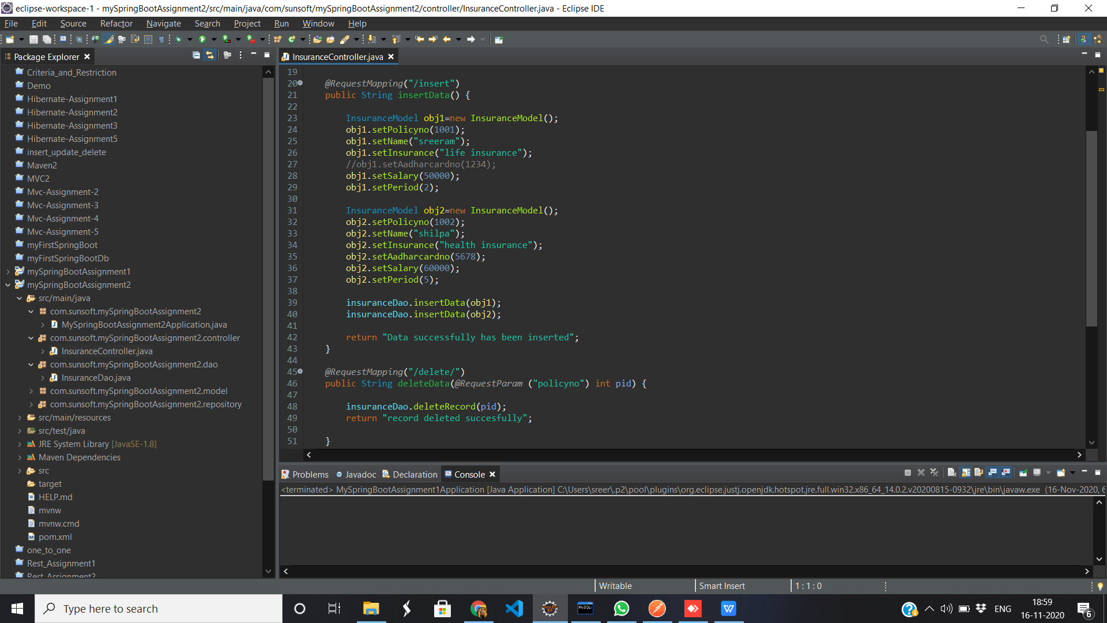

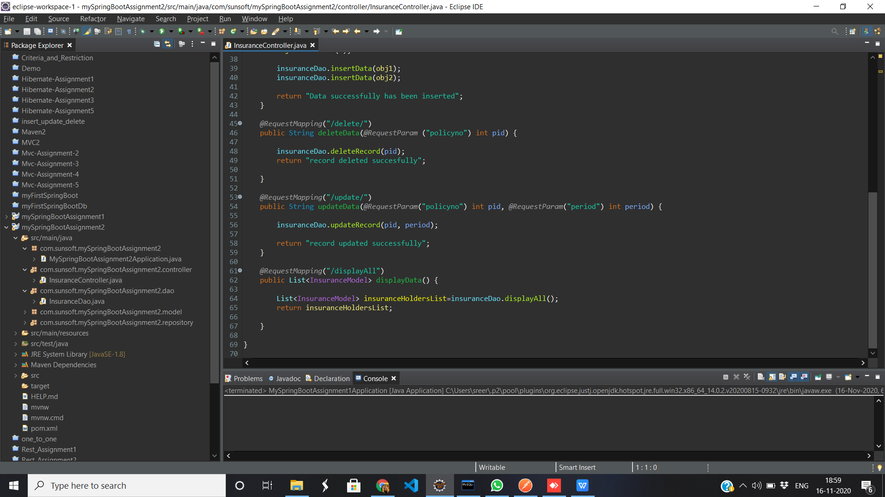

Dao Service

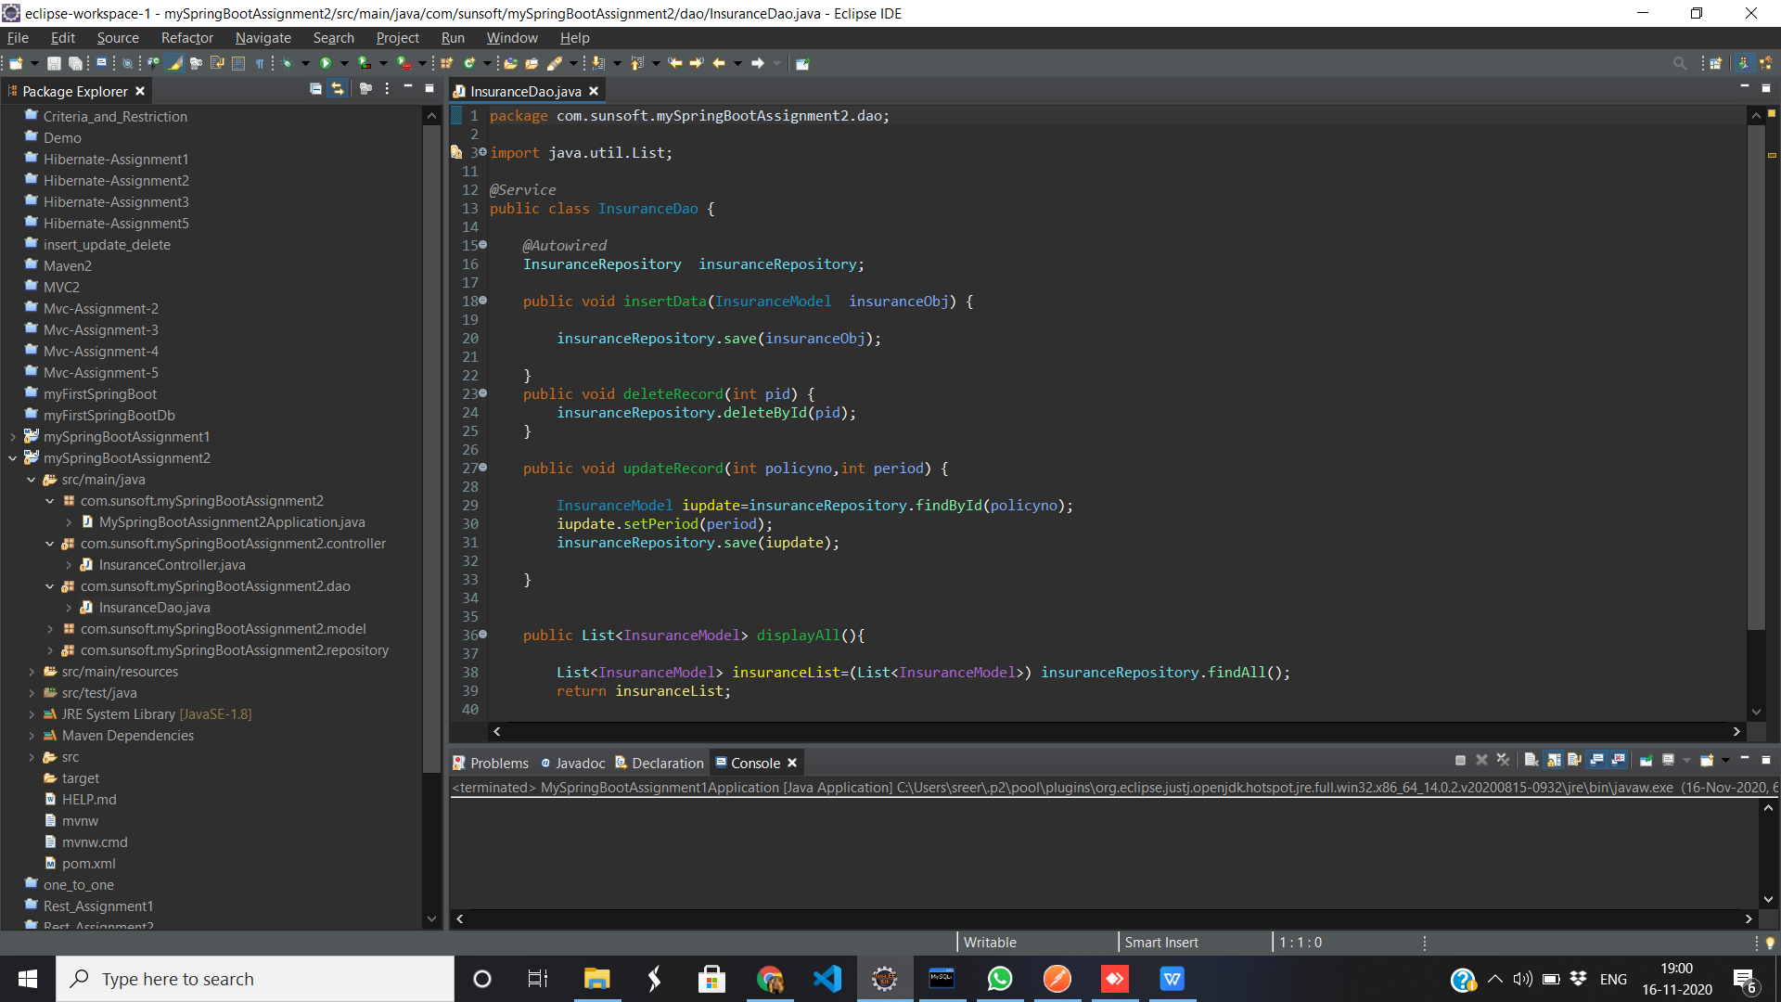

BEAN CLASS

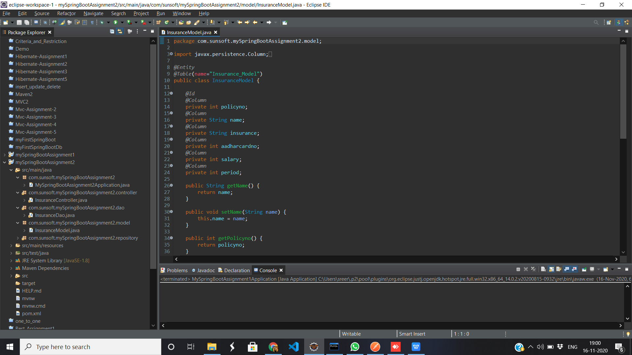

Repository Interface

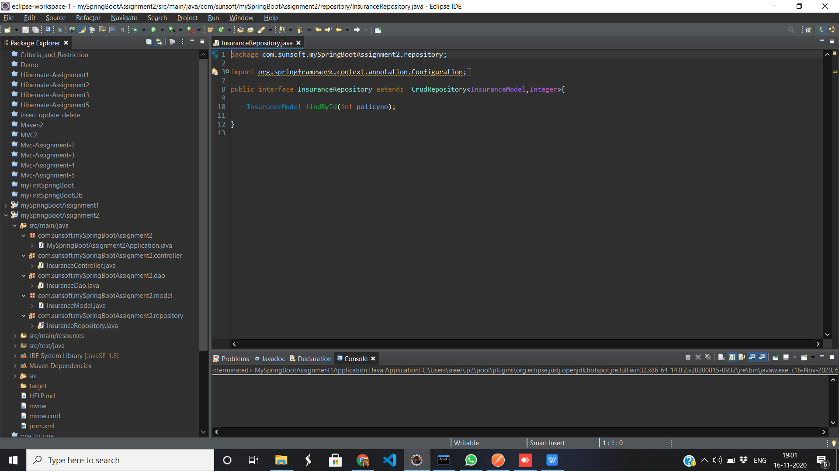

TABLE

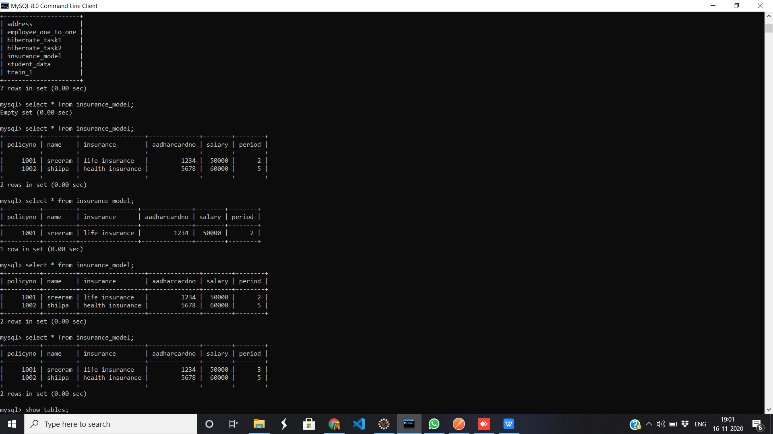

1. First select statment after insertion of data
2. Second select statement after deletion of data
3. Fourth select statement after updation of period data of row policyid=1001 where period changed from 2 to 3